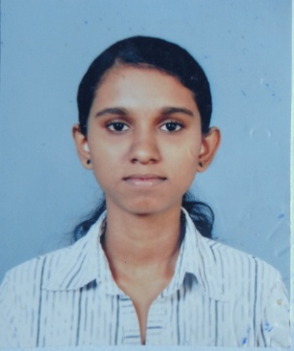P.G.Thamali Madushani Gunarathna

20, Nirmala Place, Malkaduwawa, Kurunegala

T.P- 0724169043

[Email-thamaligunarathna@gmail.com](mailto:Email-thamaligunarathna@gmail.com)

PROFILE

A final year undergraduate student specialization in Agriculture Biology in Faculty Of

Agriculture, University Of Ruhuna. Studied about micro-propagation, In-vitro culturing & mutation induction as my major.

CAREER OBJECTIVES

Young hard working agriculture undergraduate, with good logical & analytical skill, inter personal & team work skills I'm looking for a challenging career in agriculture field.

EDUCATION

2011 – 2015 B Sc. (expected) in agriculture at University of Ruhuna

Major: Agriculture Biology

Grade: Second Class Lower

Mar/2014 - Jul/2014 Institute of Personal Management (IPM)

Certificate in Human Resource Management (HRM)

Grade: Pass

Oct/2010-Feb/2011 National Institute of Business Management (NIBM)

Advanced certificate in English Language

Grade: Merit

Oct/2010-Mar/2011 ESOFT computer studies (Pvt) Ltd

Diploma in Information Technology

1996 – 2009 Maliyadeva Girls' College.

GCE A Levels: Biology [B], Physics [C], Chemistry [B].

GCE O Levels: Mathematics [A], English Language [B], Sinhala [A], Science [B], Buddhism [A], Social Science [A].

WORK EXPERIENCE

Jun/2015 – Nov/2015 Plant Genetic Resource Center (PGRC), Gannoruwa

Research trainee

PUBLICATIONS

“Study the Response of Drought Stress Inducing by Mannitol in Germination to Seedling Stage of Mung Bean (*Vigna Radiata L.*) Variety MI5 and Variety Harsha”, International Journal of Scientific and Research Publications (Volume 5, Issue 7, July 2015)

Dahanayake Nilanthi, Perera P.C.D. and **P.G.T.M. Gunarathna**

PERSONAL DETAILS

Date of Birth: 16th November 1990

Marital Status: Single

Nationality: Sri Lankan

INTERESTS

Member of Faculty Hockey team & champions in 2014 & 2015 inter faculty Hockey competition.

REFEREES

Prof K.L.Wasantha Kumara Dr Nilanthi Dahanayake ,

Head of the Department, Lecture,

Department of Agriculture Biology, Department of Agriculture Biology,

University of Ruhuna, University of Ruhuna,

Matara, Sri Lanka. Matara, Sri Lanka.

+94 412 292 200/383(office) +94 718169723(Mobile)

[Email-wasantha@agbio.ruh.ac.lk](mailto:Email-wasantha@agbio.ruh.ac.lk) Email- daha_27@yahoo.com

|  |
| --- |
|  |

I hereby certify that the above particulars furnished by me are true & accurate to the best of my knowledge.

Date: 2015 / 09 / 23 P.G.T.M.Gunarathna